**Lab 2: I/V characteristics [70]   
Grand goal:**   
(a) Design and (b) perform an experiment to determine the exact I/V characteristics of the diode 1N4148 included in your parts kit.

As discussed in the last session, the relation between current I through a diode and the “bias” voltage V applied across it is determined by the behavior of the depletion region across the internal PN junction.

The ‘ideal’ diode I/V characteristic is: (from Sze, Shockley Equation)

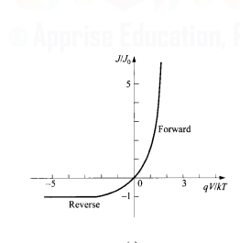

**Part (A) Circuit Design**

In a simple minded design, you could apply a voltage across the diode, measure the current, make a column-wise table and plot on graph paper. However, we hope you are not so simple minded! Many detailed time-dependent features of the device behavior are easily missed in this old-fashioned method.  
  
Design a clever circuit that allows you to get the I/V characteristic of the diode as a direct plot by plugging it into two nodes in your circuit. Here are some detailed hints:

1. The astable multi-vibrator 1kHz square wave circuit is a prerequisite (you must reuse that simulation. Some components may need to be added on)
2. As discussed, current through a two terminal (or any device, for that matter) is rather difficult to measure – it requires breaking the circuit, inserting a current probe in series etc.  
   the DSO is our only measuring device, and it only measures voltages. Hence think of a method to *indirectly* measure current through the diode. You can take advantage of the fact that the DSO probes measuring voltage have effectively ∞ input impedance and will not take any current out of your circuit.
3. A crucial feature of the astable multi-vibrator circuit as built is that it is powered by a 9V battery. Hence the output swings between ~9V and ~0V. There is a triangular ‘gnd’ symbol we put into the LTSpice simulation to allow KVL to be computed. But this 0V is NOT an absolute ground!
4. The only ‘absolute ground’ in the circuit will be the black terminal of the DSO probe wherever you choose to connect it later.
5. By default, LTSpice plots probe voltages as a function of time. However, you can replace the time axis by right-clicking on it and setting it to some other node voltage. Thus you get a plot of voltage at node 1 v/s voltage at node 2 (the solution is obvious once you crack what is 1 and 2)

There are three levels of design possible, each of which allows you to examine the behavior of the actual I/V characteristic of the diode 1N4148 in great time dependent detail, even though you’re working at a fixed 1kHz frequency.

Please give your design, circuit simulation and experimental results in the spaces provided below:

In all the designs, please make sure to NOT tweak anything within the design of the astable multivibrator circuit done before. That 1kHz square waveform generator should be kept as a fixed baseline input for this and all future labs.

**Level 1: Basic circuit design for measurement of I/V characteristic of diode 1N4148 characteristic 5**

Put your LTSpice circuit design diagram here. Highlight (a) the absolute ground location (b) the new components added and (c) the voltages to be measured

----------------------------------------------------------------------------------------------------------------------

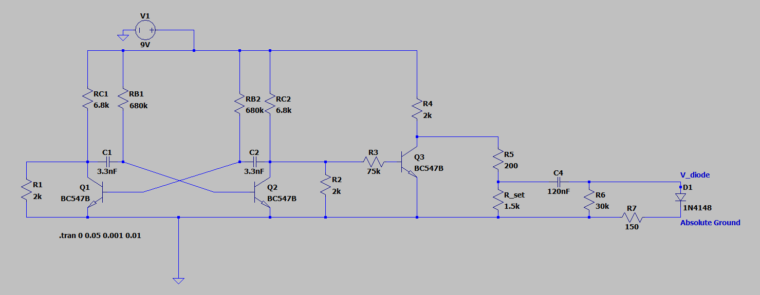

----------------------------------------------------------------------------------------------------------------------

Plot the expected results from the above simulation. **5**

Highlight using the graphics tools in Word the regions of diode going into forward/reverse bias.

----------------------------------------------------------------------------------------------------------------------

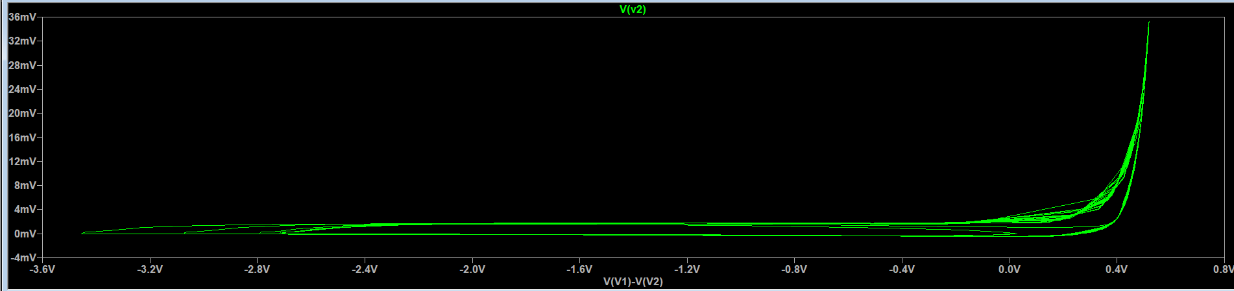

---------------------------------------------------------------------------------------------------------------------

Explain any unusual features observed in the simulated diode characteristic (you may have to do some advanced reading from Sze to understand this, or it may become clearer when you solve later parts

----------------------------------------------------------------------------------------------------------------------

**5**

In the I-V characteristic obtained, the knee Voltage is supposed to be around 0.7V, which isn’t the case here. Moreover, it is difficult to properly observe the leakage current. There is also a lot of “noise” around the knee Voltage region.

**Level 2 Design 5**

You can get an idea from the basic design that the square waveform generator is trying to slam the bias voltages across a device (diode) which has inherently finite switching time. This can cause problems…

Add some basic filtering to the output of the square waveform output to get a more ‘realistic’ diode I/V characteristic closer to the ideal shown on pg 1.  
Hint: The problem with the basic circuit setup of Level 1 is that you slam the diode voltage to full forward bias with a step function. Think about the pen-paper type of measurement: ideally you would like to increase/decrease the diode forward voltage gradually and observe the corresponding diode current (Also refer to Sze notes to understand any artefacts you observe from simulation at Level 1)

Put your circuit design and its corresponding simulated output plots here

----------------------------------------------------------------------------------------------------------------------

We apply a high pass filter in this level.

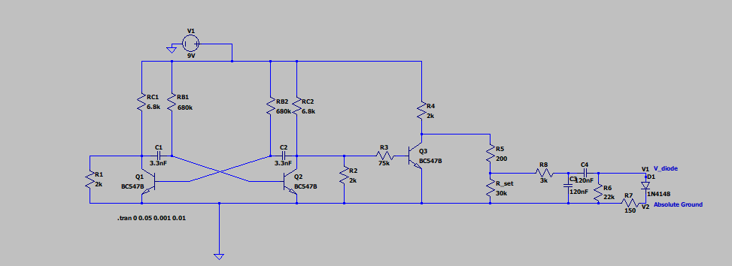

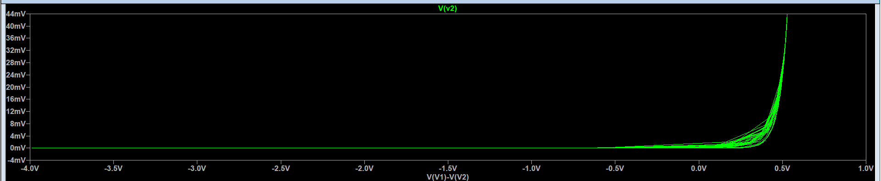

**Level 3 Design 5**

By this level, you should have understood the full constraints of smoothly varying the diode bias voltage to measure its current as it enters/exits the different modes of operation. With this big picture in mind, design a complete end-to-end circuit you can build starting with the 1kHz square waveform generator to determine the full I/V characteristics of a two terminal diode 1N4148.

As before, highlight carefully the new parts added, and the measurement points  
Hint: Level 3 design is expected to be slightly more complex than Level 2 (and hence Level 1): the main issue we want to attack is that we want swing the bias voltage across the diode between positive and negative bias, preferably at the *same* rate to observe experimentally the I-V characteristic in 1st and 3rd quadrants of the I-V plot and any time-dependent features as discussed in Sze

Put your circuit design and its corresponding simulated output plots here:

----------------------------------------------------------------------------------------------------------------------

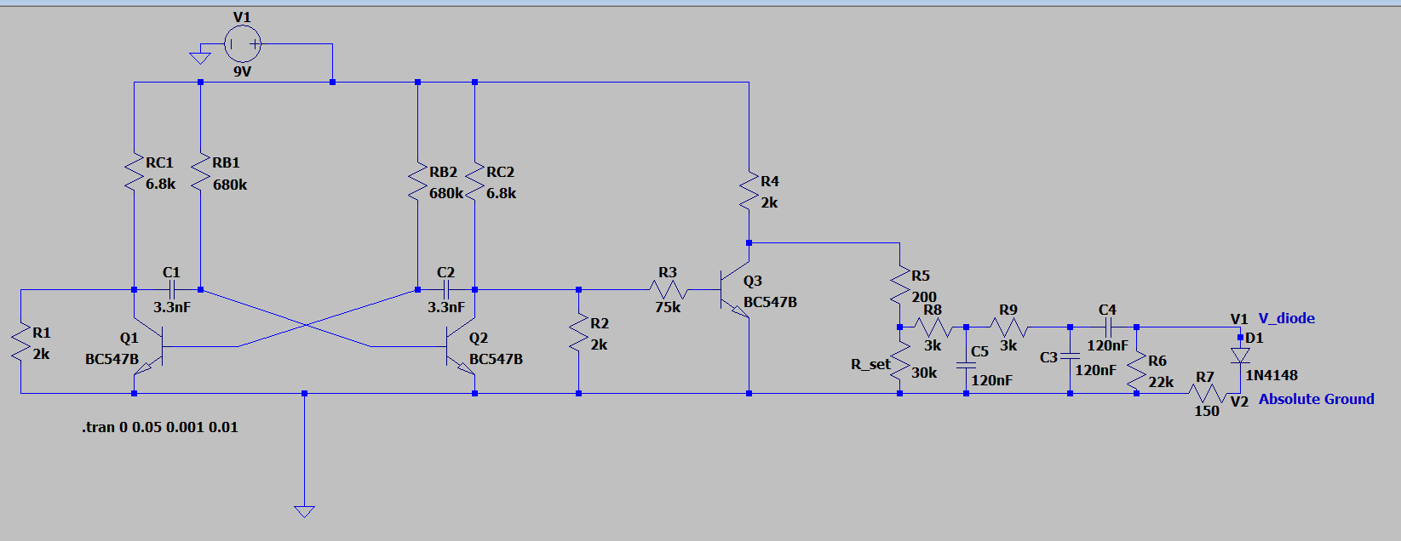

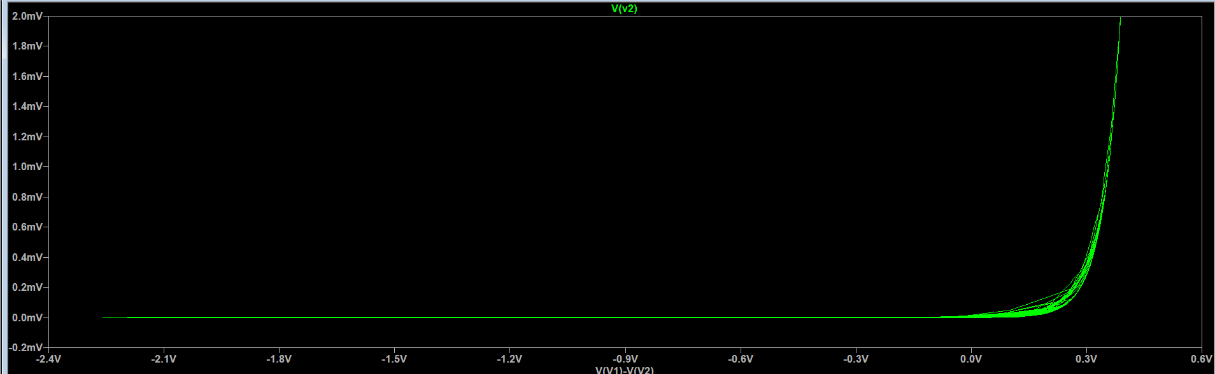

**Part (B) Circuit Build and demo: I/V of diode 1N4148**

Now that you have a confidently designed circuit with a clear idea of what to measure, build your circuit on the breadboard.   
You should already have the 1kHz square waveform generator from Lab 1 built-up on your breadboard.

B.1) Put a photo of your breadboard with built up astable multi-vibrator circuit from Lab 1 with the measured output 1kHz on DSO **10**Note: your photo must include the breadboard, the battery, the DSO display   
*and your ID card placed next to the breadboard*

----------------------------------------------------------------------------------------------------------------------

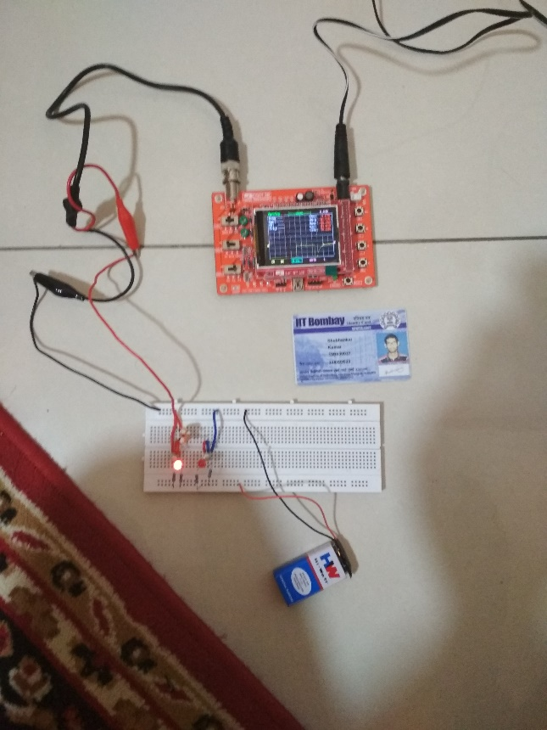

B.2) As in B.2, provide a photo of filtered output from circuit you have built based on design Level 3 of Part A to drive the I/V characterizer **5**----------------------------------------------------------------------------------------------------------------------

B.3) Egad‼ you realize that your DSO has only a single analog input, so you are only able to probe one voltage at a time! The simulated output of plotting one voltage against another was a pipe-dream! Or, was it?? (**25)**

It is still possible to interpret the measurements and get precise quantitative answers, including the time-domain behavior of the device that would not be possible with the old-fashioned [measure, write, plot-on-graph, fit curve] method.

Provide photos of your measurements (DSO screen, ID card, omit breadboard for this one – you will need to examine details of the measured waveform on your DSO screen)

----------------------------------------------------------------------------------------------------------------------

*DSO only measures voltages as a function of time you will have to fine tune the trigger settings to get a stable measurement. Highlight on your photos, the region where the diode is in forward and reverse bias*

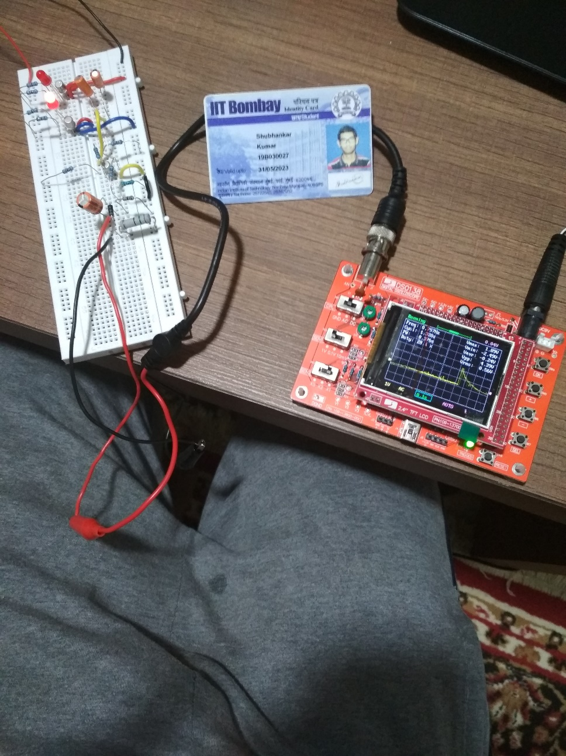

Interpret the voltages you are able to measure using single DSO probes sequentially (take separate photos to be put in above). Determine the following measurable quantities:

1. What is the maximum forward current Imax|forward up to which your circuit is able to drive the diode in forward bias? **5**

----------------------------------------------------------------------------------------------------------------------

50 μA

2. Correspondingly, what is the maximum forward bias voltage at which this Imax|forward is driven **5**

----------------------------------------------------------------------------------------------------------------------

0.6V

3. What is the maximum reverse bias voltage applied to the diode? **5**

----------------------------------------------------------------------------------------------------------------------

-0.9V

4. When the diode bias voltage falls below the turn on threshold, does the diode current fall to zero immediately as expected from theory? If not, why not? When the bias voltage goes to reverse bias, do you observe opposite sign leakage current in the diode in the 3rd quadrant of I/V as shown in pg 1 ideal diode characteristic? **10**----------------------------------------------------------------------------------------------------------------------

No, the current doesn’t fall immediately as expected from theory.

Yes, the leakage current in the diode can be observed from the plot.